Git Setup

Download git in local and you will find this git bash:

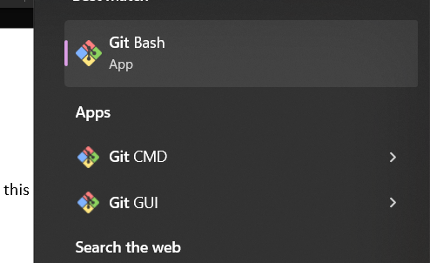

Commands in git bash:

1. **mkdir**: to create new directory
2. **cd**: to get inside a particular directory
3. **ls**: to list the file inside

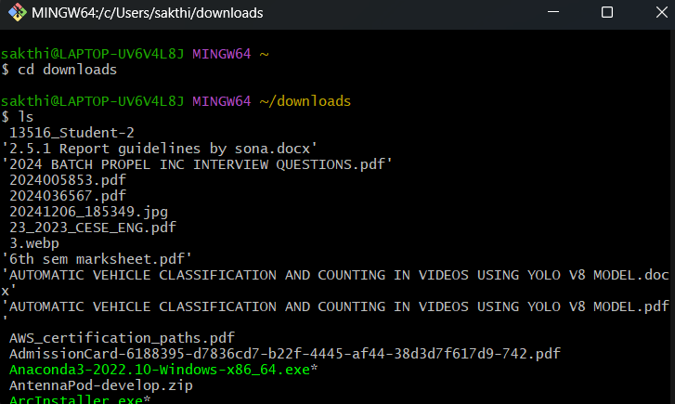

1. **pwd**: gives the path of the current directory (Print Working Directory)

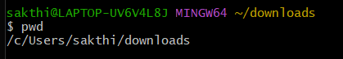

1. **git config --list**: you want to see your git user name and email configured here. (in below image it is not conf yet)

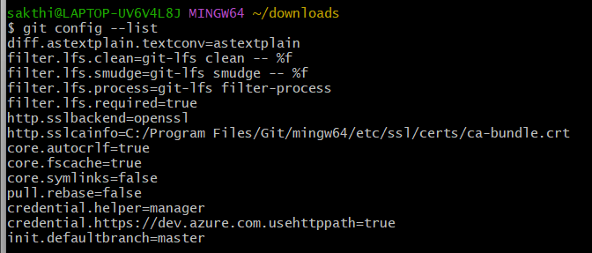

1. if configuration (step 6) is skipped then two branches will be there
2. main
3. master (your local pc copy)

if you try to push the changes. It will create a pull request in the main branch in GitHub. Only is the main branch can decide that change should be adopted or not.

**way 1: with --global**

**git config --global user.name "Git Name"**

**git config --global user.email “gitemail@example.com”**

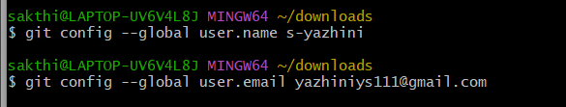

**Way 2: without --global**

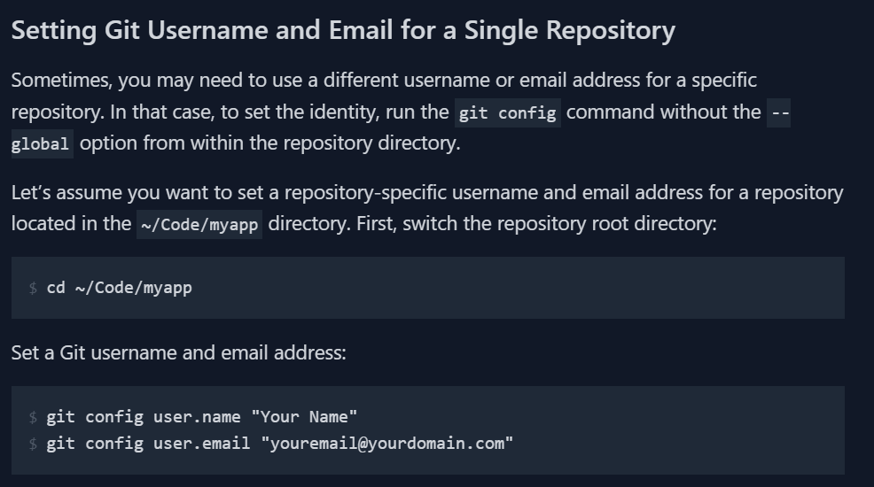

1. git config –list

After previous step, now you can see your name and email configured

Even if you close your entire git bash and open again you should find this configured thing.

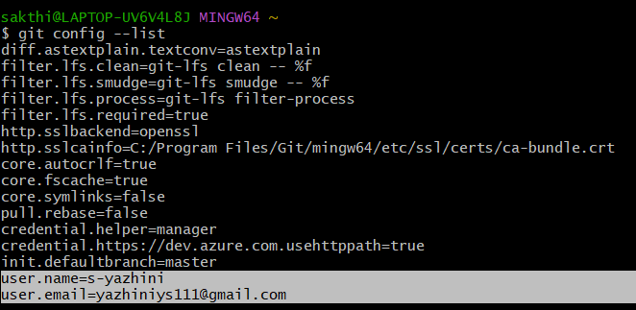

1. **git clone “repo_link”** (or you can **init a fresh repo** from part 2 step 1)

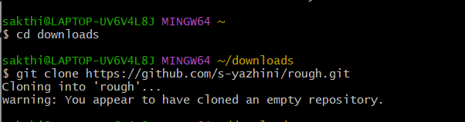

1. **git pull** (must because changes you made in github should not create any **conflict**)

note that (main) symbol:

if configuration (step 6) is skipped then two branches will be there

1. main
2. master (your local pc copy)

if you try to push the changes. It will create a pull request in the main branch in GitHub. Only is the main branch can decide that change should be adopted or not.

before pull: (initially no file inside this repo)

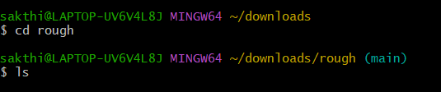

After pull: (a new file/change made in github get pulled here also. So, no conflict)

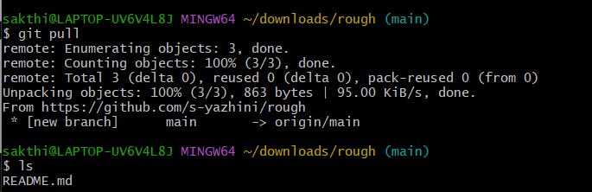

1. **touch <any file name>**: to create a file





1. **git status:** checks the status of the above file (committed to main repo or not)

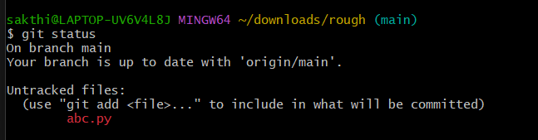

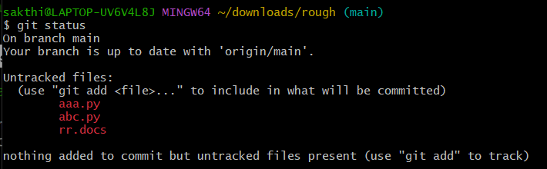

1. **git add: (to stage** the files that want to be commited)



1. **git commit -m “<commit msg>”**

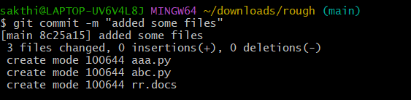

1. **git push**

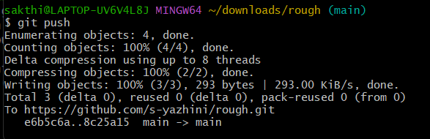

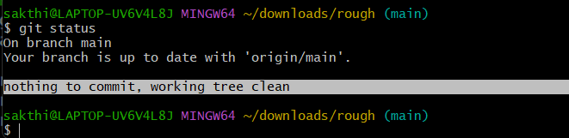

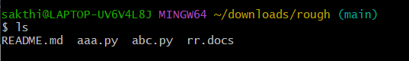

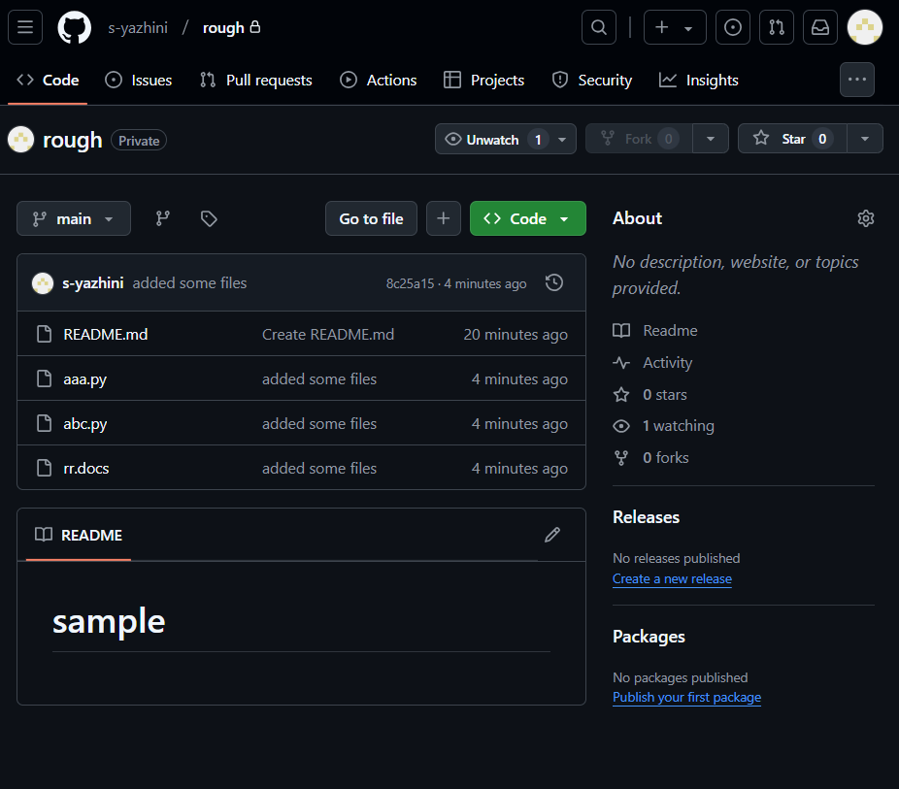

1. **history**

